**Student Engagement Analysis in Virtual Class Using Natural Language Processing**

Asst. Prof. Balamurugan M [1], Dhanush G [2]

*Department of Computer Science and Engineering,*

*Sona College of Technology, Salem, Tamil Nadu, India*

*Email:* [*balamurugan.cse@sonatech.ac.in[1*](mailto:balamurugan.cse@sonatech.ac.in[1)*], dhanushg.20cse@sonatech.ac.in [2],*

**Abstract:** The shift to digital education has become imperative, particularly during pandemic situations, leading to an increased reliance on online classes. However, teachers face challenges in gauging student involvement and understanding in virtual environments. This research explores the use of NLP techniques, including the BERT model for understanding relationships among words and bag of words for identifying overlapping words between paragraphs, to address these challenges. We propose a method where teachers make notes about lectures and encourage students to take notes in each class. These notes are then analysed using NLP algorithms to trace each student's overall understanding and track how their comprehension evolves over time. The study aims to evaluate how students' understanding and involvement in virtual classes can be enhanced through NLP analysis. We present a portfolio that visualizes the overall understanding graph of each student and their understanding score for each class, providing insights for improving virtual teaching methodologies and student learning outcomes.

**Keywords:** Digital education, Online classes, Student involvement, Comprehension tracking, Virtual teaching methodologies, Student learning outcomes

1. **INTRODUCTION**

The way we learn has changed a lot with everything going digital, especially during tough times like the recent pandemic. Online classes have become the new normal, but they come with their own challenges, especially for teachers. One big challenge is figuring out how well students are really understanding and engaging with the lessons in virtual classes. To tackle this challenge, our research dives into the world of Natural Language Processing (NLP), a fancy term for how computers understand human language. We use NLP to analyse the notes students take in online classes, giving us a peek into how well they are understanding and participating in the lessons.

One cool tool we use is called the BERT model. It is like a language detective, sniffing out the meanings behind words in the notes. By using BERT, we can see how much of the teacher's content is getting through to each student. This helps teachers adjust their teaching to make sure everyone is on the same page. Another trick up our sleeve is the bag-of-words technique. This one helps us spot if students are copying from each other by looking at the words they use in their notes. It is like a plagiarism police for online classes, helping keep things fair and honest. To make things even more interesting, we've created a special website for teachers. This website, made with a tool called Stream lit, is like a digital command centre. It stores all the notes and analyses them using an SQLite database. Then, we use cool visual tools like Matplotlib and Plotly to show the data in easy-to-understand graphs and charts.

Our goal is to help teachers better understand how their students are doing in online classes. With our research, we hope to make online learning more engaging and effective for everyone involved, even when we cannot be in the same room together.

1. **RELATED WORKS**

Suhye Kim et al. investigated elementary students' behaviours in low attention states during online learning using EEG, identifying characteristic movements from webcam videos [1]. Su et al. (2021) introduces a non-intrusive video analytic system utilizing deep learning for real-time monitoring of in-class student learning behaviours, including facial expressions and gestures. Their approach, compatible with edge devices, offers automatic feedback to instructors, enhancing situational awareness and potentially improving learning outcomes in modern educational settings [3]. Li et al. propose an intelligent monitoring algorithm for students' online learning behaviour based on user portraits, utilizing demographic, academic, behavioural, and psychological attributes. This research aligns with our project's objective of understanding student engagement and comprehension in online classes, potentially informing the development of algorithms for analysing student behaviour and performance using demographic and behavioural data.[10]

Alzahrani et al. (2021) examines various forms of plagiarism, distinguishing between literal and intelligent plagiarism behaviours. Their taxonomy of plagiarism types and survey of detection methods inform our project's development of NLP tools to detect plagiarism in online class notes, complementing our focus on student engagement and comprehension analysis [2].Blanco and Moldovan (2015) propose a semantic logic-based method for determining textual similarity, leveraging logic form transformations and supervised machine learning. Their approach considers semantic structure to improve similarity scores, showing performance enhancements compared to baseline methods and third-party systems. This work aligns with our project's objective of utilizing NLP techniques to analyse textual content in online classes, potentially contributing to the development of more accurate similarity detection algorithms [4].

Zhen et al. propose a novel approach utilizing natural language processing and deep learning to predict academic performance based on dialogue analysis in online classrooms. Their findings highlight the significance of emotional expression and interactive types in distinguishing high- and low-performing students across STEM and non-STEM courses, contributing valuable insights to the field of educational analytics.[5] Aboutaleb et al. propose the BERT BiLSTM-Attention Similarity Model, enhancing the accuracy of question similarity calculation in Question Answering Systems. By leveraging BERT for embedding and BiLSTM-Attention for feature extraction, the model achieves an 84.45% accuracy in determining question similarity, demonstrating its efficacy in improving semantic similarity models for NLP applications.[6]

Tekgöz et al. introduce a novel method for measuring semantic similarity in texts, focusing on sentence and short paragraph comparison. Their approach combines a corpus-based measure of semantic word similarity with a modified Longest Common Subsequence (LCS) algorithm. Evaluation on two datasets demonstrates superior performance compared to existing methods, indicating its potential for applications in textual knowledge representation and discovery in the field of health.[7] Halak and El-Hajjar address the detrimental effects of plagiarism in education and propose two techniques for detection and prevention, emphasizing the importance of fostering creative thinking and maintaining trust between educators and students.[8]Qader et al. provide an overview of the Bag of Words (BoW) method, highlighting its significance, implementation, applications, and challenges. This study could inform our project by offering insights into the use of BoW for text classification, which aligns with our goal of analysing student notes in online classes using Natural Language Processing techniques like BoW to detect plagiarism and assess comprehension.[9]

1. **MATERIALS AND METHODS**

**3.1 Data Collection**

We began by collecting student notes from online classes as Real time Dataset. We also use to extract the similar content written by different authors in various platforms using web scraping techniques which is used for training purposes. This involved using the Beautiful Soup module in Python to extract the notes from various online platforms and tools used for classes and note-taking. By gathering notes from diverse sources, we aimed to create a diverse dataset that could provide a comprehensive view of student engagement and comprehension which is shows in below image Figure3.1

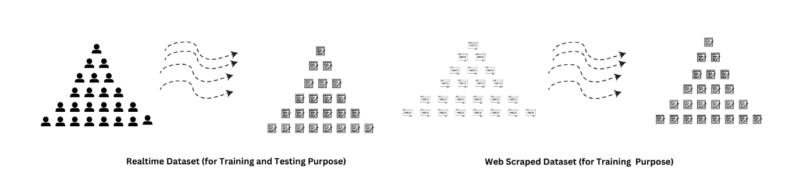

**Figure: 3.1** Data Collection from Various Sources

**3.2 Preprocessing**

Before analysing the notes, we pre-processed them using natural language processing (NLP) techniques. This step included removing stop words, tokenization (splitting the text into individual words or tokens), and cleaning the text using NLTK, SpaCy, and regex-based functions. Preprocessing was essential to ensure that the text was in a standardized format and ready for analysis. After these steps we convert the pre-processed data into machine understandable form and so we use word2vec method in NLP for converting these words into numbers which ML models use to train and validate the dataset. This preprocess steps flow is illustrated in below figure 3.2.

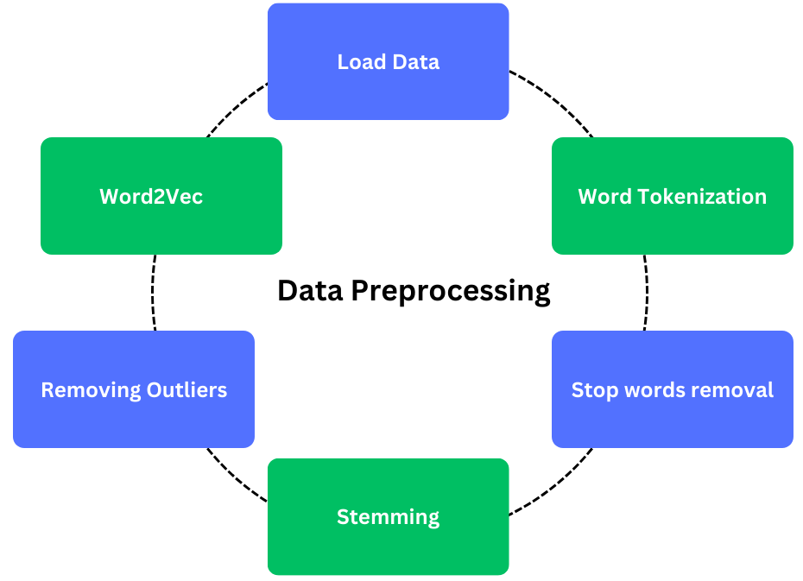

**Figure: 3.2** Workflow of Data Preprocessing

* 1. **MODEL WORKING**

To identify similar paragraphs within the notes, we employed AI models like GPT and BERT. These models can understand the context and meaning of text, allowing us to retrieve paragraphs with similar meanings. This process helped us gain insights into students' comprehension levels and the effectiveness of teaching materials.

* + 1. **BERT MODEL**

We use the BERT Model to find similarities between Student Notes with Teacher Notes. BERT Model only processes the embedding vector data. So, in the previous step, we pre-processed the data and converted it into vectors with some pre-processed data. Then we perform the Word embedding to capture the relationship between the words in a sentence. The BERT Model does not perform sequential data processing, instead, it processes the data from both ends to understand the meaning of the sentence. Then we use the any of NLP similarity measures like cosine similarity etc… to calculate the similarity score between two paragraphs means Student note and Teacher Notes for understanding how they are like analyse the student engagement in the virtual class which is illustrated in the below figure 3.3.1

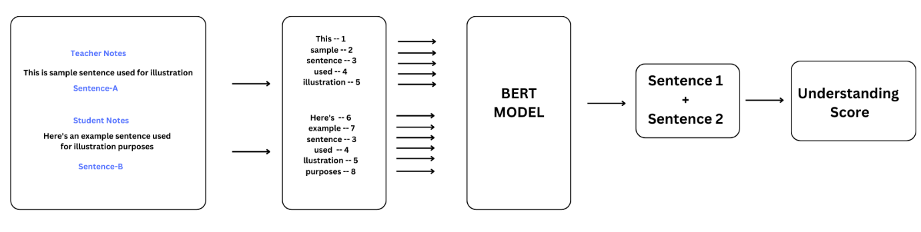**Figure 3.3.1** Working of BERT Model

* + 1. **BOW MODEL**

To detect plagiarism among student notes, we employed the Bag-of-Words (BoW) model. This Model also only accepts the vectorized data. So, for this model also we feed only the vectorized data it analyses the by noticing the overlapping words between the notes. We feed student notes to find weather the student copies the content from other student that can be noticed with help of this model which is shown in the below figure 3.3.2

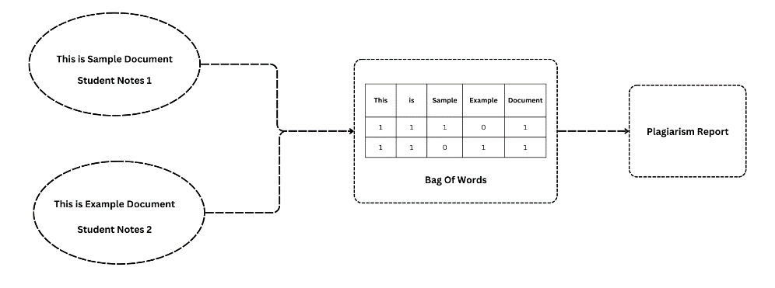

**Figure 3.3.2** Working of BoW Model

* 1. **VISUALIZATION-PORTFOLIO**

This Streamlit application, titled "Student Portal," serves as a multifunctional tool for students. It allows users to log in securely and access various features such as uploading notes, viewing guidelines from teachers, clarifying doubts, and analyzing individual performance through interactive plots showing understanding over time and understanding versus difficulty. Through a user-friendly interface, students can efficiently manage their academic tasks and track their which is shows in figure 3.4.1

The Teacher Portal offers educators a comprehensive platform to manage academic tasks efficiently. With secure login credentials, teachers can upload guidelines, view individual student understanding levels, and analyze overall class performance through interactive visualizations. The portal enhances collaboration by providing features for clarifying doubts and offering guidance, fostering a dynamic and supportive learning environment which is shows in figure 3.4.2

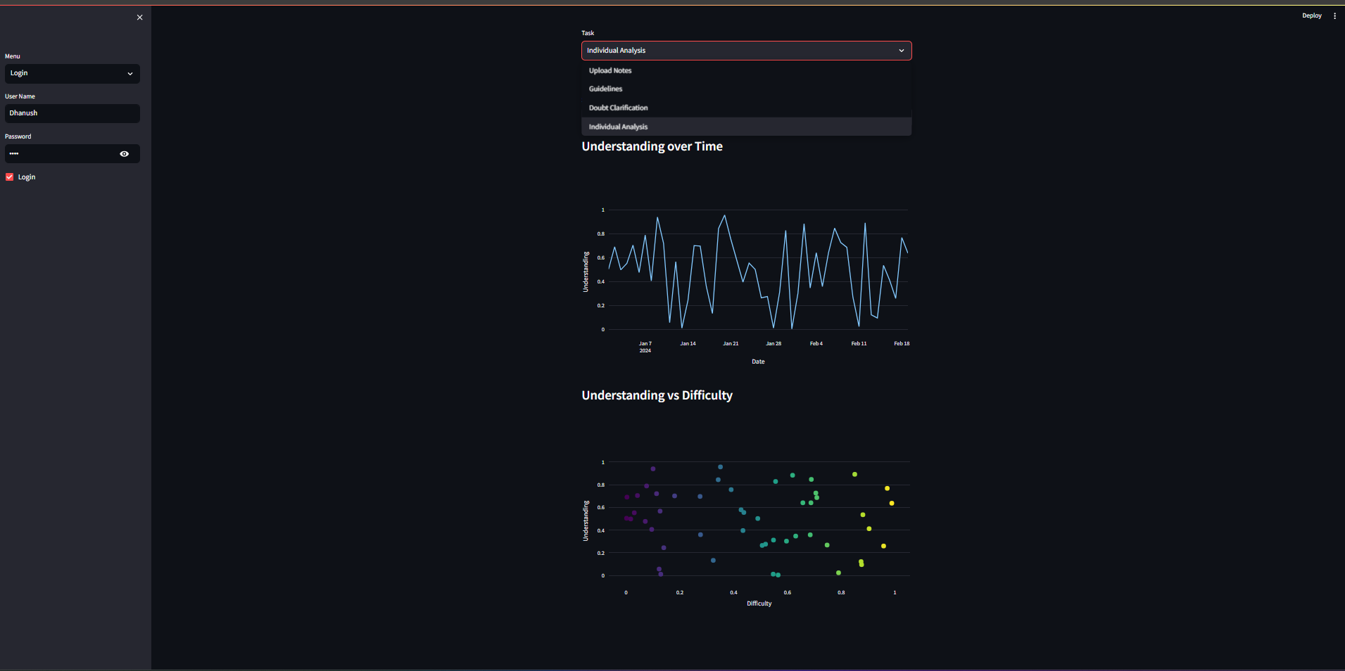

**Figure 3.4.1** Student Portfolio

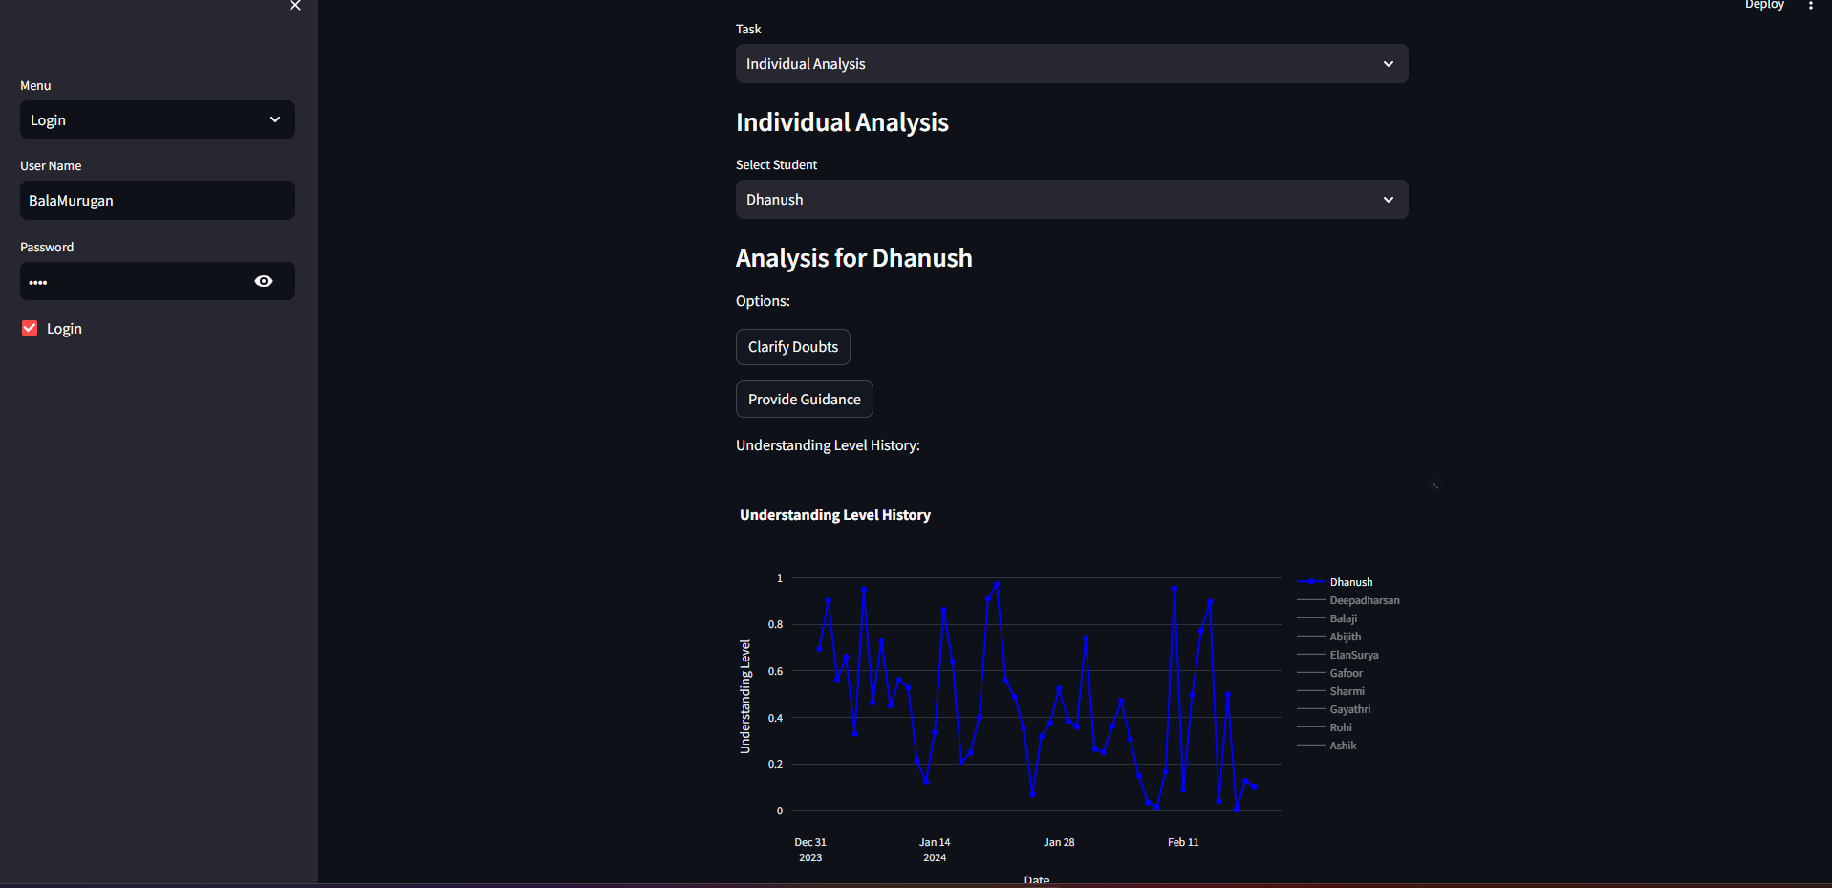

**Figure 3.4.2** Staff Portfolio

1. **WORKING**

In our study, we aimed to elevate our model's text comprehension and comparison skills by incorporating a diverse range of content. To achieve this, we employed web scraping to gather text data from various websites, ensuring our model was exposed to a variety of writing styles and topics. This approach enabled us to construct a robust training dataset imbued with different perspectives and writing nuances, enhancing our model's adaptability and capacity to process various text inputs creatively.

To enrich our model's training data and enhance its performance, we integrated cutting-edge AI-based models like GPT and BERT. These models allowed us to generate diverse writing styles for identical content, imparting a broader understanding of language and context to our model. By incorporating these AI models, we sought to improve our model's text recognition and generation capabilities, resembling human writing styles more closely and enhancing its effectiveness in analysing and comprehending text data.

Following the collection and preparation of the data, we meticulously pre-processed it to cleanse and standardize the text. This involved removing extraneous information such as stop words and special characters using regex, as well as identifying and eliminating anomalies. This preprocessing step ensured that our model was trained on high-quality, standardized text, which is critical for precise analysis and evaluation. Subsequently, we fine-tuned the collected data and trained it using the BERT and BoW models. BERT aided us in identifying text patterns, enabling us to calculate similarity scores between different text sets. This facilitated our assessment of the similarity between various documents, offering valuable insights into the nature of the text and enhancing our model's ability to understand and compare text data effectively.

Additionally, the BoW model played a pivotal role in our research by utilizing cosine similarity to identify overlapping words between paragraphs. This method assisted us in detecting plagiarism and ensuring the integrity of the text data used in our research, further enhancing the reliability and accuracy of our model's analysis. In summary, our study employed a comprehensive approach that integrated web scraping, AI models, preprocessing techniques, and advanced models like BERT and BoW to enhance our model's ability to recognize and evaluate text similarity. By amalgamating these techniques, we aimed to elevate the quality and effectiveness of our model in analysing and understanding text data, particularly in the realm of online learning.

Figure 4.1 illustrates the procedural steps for analyzing student engagement in a virtual classroom environment through Natural Language Processing (NLP). This workflow delineates the process of leveraging NLP techniques to assess and understand the levels of student engagement during virtual class sessions.

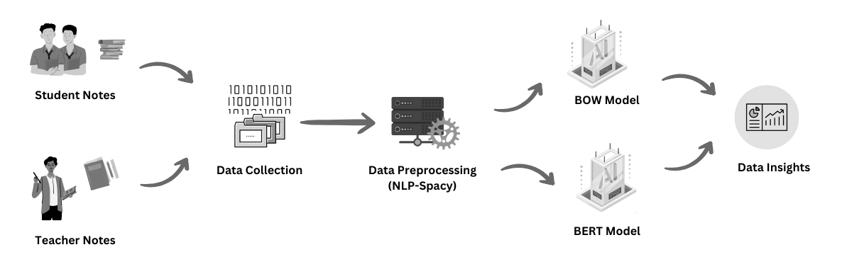

**Figure 4.1** Workflow of Student Engagement Analysis in Virtual Class Using Natural Language ProcessingTop of Form

1. **EXPERIMENTAL RESULTS**

The model underwent training for a total of ten epochs, with each epoch processing a batch size of thirty-two. During training, the binary crossentropy loss function was utilized, alongside accuracy as the primary evaluation metric. Progress updates were displayed throughout the training process with a verbosity level set to 1. Upon completion of the training phase, the model underwent evaluation using a separate test dataset. The test results revealed a loss value of 0.51 and an accuracy rate of 75%. The performance evaluation showcased a test loss of 51% alongside a corresponding test accuracy of 75%, providing a foundational assessment of the model's capabilities.

1. **CONCLUSION**

In summary, our research has showcased the power of combining innovative techniques to enrich text analysis. By blending web scraping with advanced AI models like GPT and BERT, as well as employing meticulous preprocessing, we have significantly boosted our model's capacity to grasp and compare text. Through web scraping, we curated a diverse array of content, ensuring our model learned from a broad spectrum of writing styles and topics. The integration of AI models such as GPT and BERT enabled us to generate a myriad of writing styles for the same content, deepening our model's comprehension of language and context. Preprocessing techniques further refined the text data, guaranteeing our model trained on top-quality, standardized text.

Our approach of employing BERT for pattern recognition and BoW for plagiarism detection proved particularly effective in scrutinizing text similarity. BERT's prowess in identifying underlying patterns, coupled with BoW's knack for pinpointing plagiarism by comparing words between paragraphs, provided insightful glimpses into text similarity and integrity. These strategies significantly heightened the reliability and precision of our model's analyses. Our study underscores the transformative potential of integrating these methodologies in text analysis, especially in the realm of online learning. By enhancing our model's ability to discern and assess text similarity, we aspire to pave the way for more sophisticated and efficient text analysis tools across various domains.

1. **FUTURE WORKS**

In future developments, while we aim to enhance our portfolio platform to better support students in tracking their progress and engagement in virtual classes, we anticipate certain limitations. Specifically, while our recommendation engine will utilize student notes to suggest relevant study materials, its effectiveness may be constrained by the availability and quality of the input data. Additionally, our AI-powered system to simplify lecture content may face challenges in accurately summarizing complex concepts, particularly in mathematical and language-specific contexts. Moreover, although we intend to create an online repository for lecture content to facilitate self-paced learning and revision, the accessibility and comprehensiveness of the materials may vary. Lastly, while our AI-powered doubt resolution bot aims to provide simplified explanations for complex topics, its efficacy may be limited in addressing nuanced queries or highly technical subjects. Despite these potential limitations, our overarching goal remains to enhance the virtual learning experience by offering personalized support and resources to students.

1. **REFERENCE**
2. Suhye Kim, Jung-Hwan Kim, Wooseok Hyung, Suhkyung Shin, Myoung Jin Choi, Dong Hwan Kim, and Chang-Hwan Im. “*Characteristic Behaviors of Elementary Students in a Low Attention State During Online Learning Identified Using Electroencephalography.*” IEEE Transactions on Learning Technologies, Volume 17, June 2023. DOI: 10.1109/TLT.2023.101682811.
3. Salha M. Alzahrani, Naomie Salim, and Ajith Abraham. *“Understanding Plagiarism Linguistic Patterns, Textual Features, and Detection Methods.*” IEEE Access, Volume 9, 2021. DOI: 10.1109/ACCESS.2021.30563102.
4. Mu-Chun Su, Chun-Ting Cheng, Ming-Ching Chang, and Yi-Zeng Hsieh. “*A Video Analytic In-Class Student Concentration Monitoring System.”* IEEE Transactions on Multimedia, Volume 18, Issue 7, July 2016. DOI: 10.1109/TMM.2016.25482983.
5. Eduardo Blanco and Dan Moldovan. “*A Semantic Logic-Based Approach to Determine Textual Similarity*.” Journal of Artificial Intelligence Research, Volume 24, 2005 4.
6. Krithika and Lakshmi. “*Prediction of Academic Performance of Students in Online Live Classroom Interactions — An Analysis Using Natural Language Processing and Deep Learning Methods*.” Journal of Social Computing, Volume 4, Issue 1, March 2023. DOI: 10.1007/s42452-023-00195-15.
7. Ahmed Aboutaleb, Ahmed Fayed, Dina Ismail, Nada A. GabAllah, Ahmed Rafea, Nourhan Sakr “*BERT BiLSTM-Attention Similarity Model*,” IEEE Access, Issue 02 August 2021. DOI: 10.1109/ICAICA52286.2021.9498209
8. Hilal Tekgöz, Halil İbrahim Çelenli, Sevinç İlhan Omurca,” *Semantic Similarity Comparison of Word Representation Methods in the Field of Health*,” IEEE Access, Issue 13 October 2021, DOI: 10.1109/UBMK52708.2021.9558891
9. Basel Halak, Mohammed El-Hajjar, “*Plagiarism detection and prevention techniques in engineering education*,” IEEE Xplore, Issue 23 June 2016, DOI: 10.1109/EWME.2016.7496465
10. Wisam A. Qader, Musa M. Ameen, Bilal I. Ahmed “*An Overview of Bag of Words; Importance, Implementation, Applications, and Challenges*,” IEEE Access, Issue 09 January 2020, DOI: 10.1109/IEC47844.2019.8950616
11. Gang Li, Hai Fu, Yaowen Sun, Yong Zhang “*Intelligent Stable Monitoring Algorithm of Students' Online Learning Behavior Based on User Portrait*,” IEEE Access, Issue 14 November 2022 DOI: 10.1109/PHM-Yantai55411.2022.9941842